**School of Nursing and Allied Health**

**Student Uniform Policy: Version 1 (2023)**

# 1. Introduction

This policy outlines the standards which must be adhered to by all students when in practice settings in order to ensure risk is minimised to all services users, students and staff. Please note that these are the *minimum* standards which you are to adhere to, and you should always comply with Trust/organisational policies when on placement which may differ materially from this policy. For the purpose of clarity, whenever “*clinical practice*” is mentioned this also includes simulated practice activities (both on University premises and elsewhere) and activities in the clinical skills environment, unless otherwise advised by University staff.

It is the students responsibility to check uniform requirements for each placement prior to attendance and ensure compliance at all times.

This policy is based upon existing evidence and is based upon the principles contained within the NHSE/I Uniforms and workwear guidance which can be accessed here

<https://www.england.nhs.uk/publication/uniforms-and-workwear-guidance-for-nhs-employers/>

**2. Why should healthcare professionals wear a uniform?**

Patient safety

It is every healthcare professionals duty in doing their utmost in preventing infection transmission wherever possible. Hand hygiene is obviously a significant factor in this but it is also considered that uniforms and workwear play a direct role in this too. A uniform should not impede a healthcare professionals ability to perform effective hand hygiene, nor should it provide a possible vector for the transmission of infection. Nothing that a healthcare professional wears which could compromise a patient/service users safety during care, for example rings, earrings, necklaces, wristwatches, nails (and nail products) and studs.

Public confidence

The way a healthcare professional dresses can have a positive impact upon the public’s perception of the standards of care they experience. The public rightfully have the expectation that healthcare professionals are upholding standards of care and reducing the risk of infection, and the wearing of a clean, well -presented uniform can help to fulfil this expectation. Uniforms (including name badges) can help members of the public to identify staff in the care environment.

Staff comfort

Dressing comfortably in a uniform which allows the healthcare professional to move freely can enhance the workplace experience, reduce fatigue and the potential risk of injury. There needs to be a healthy balance between being able to dress in accordance with a persons cultural and religious practices and maintaining the need to perform effective hand hygiene whilst upholding the duty of care as per NMC/HCPC standards. This includes the need to be “bare below the elbow” when performing direct patient care.

**3. Who does this apply to?**

This policy applies to all students from the School of Nursing and Allied Health when engaged in placements (this included simulated placements) and when engaged in clinical skills labs activity (unless otherwise advised by University staff).

# 4. Uniform issue

You will be provided with sufficient uniform on commencement of your chosen programme of study and this intended to last for the duration of the course. If uniform is required to be replaced during your programme of study then you will be responsible for acquiring this. You may only wear the approved uniform provided and must not substitute any of the items provided for your own clothing. If replacements are required then you must only use the University’s approved uniform supplier. If you become pregnant during the course of your studies then maternity garments can be provided on request, and you should contact the Faculty office to obtain these. At the end of your studies you should cut out and destroy the University logo and text and recycle the garments at an appropriate facility. Any items which were issued as loan, e.g. paramedic helmets should be returned to the Faculty office otherwise you may be charged.

# 5. Modifications to uniform

Wearing of head scarves (e.g. Hijab) is permitted. Scarf must be changed daily. Scarf must be plain and either black or in a colour matching the uniform. Scarfs must not hang under the shoulder and must be tucked in under the uniform. The wearing of full-face veils (e.g. Niqab) is not permitted in clinical practice as this may impede effective communication with patients and therefore presents a clinical risk.

Bare below the elbow is required for all students within clinical areas or care setting such as the patient’s home. When involved in patient contact students must be bare below the elbow to enable effective hand hygiene.

In certain circumstances it may that a placement provider requires that you do not wear a uniform and you should be guided by that providers guidance and policy in those circumstances. Unless otherwise requested to do so by a placement provider, you should wear your University supplied uniform to all placement experiences. In those exceptional circumstances where you many not be require to wear uniform then the following dress code applies: no denim, no revealing clothing which exposes underwear or abdomen/lower back, no dirty, ripped or frayed clothing, no excessively short skirts or dresses, leggings should only be worn under skirts or dresses, no high heels, no clothing which portrays an unprofessional image.

# 6. Footwear

Footwear is to be provided by the student and must be dark in colour without visible logos, pictures or words and be of supportive non-slip and wipe-able closed over the foot, heel and toes. Trainers, shoes with a raised, sandals and CROCS™ are not permitted. See below for examples.

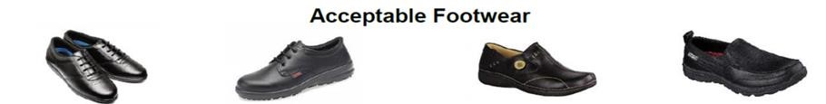

# Unacceptable Footwear

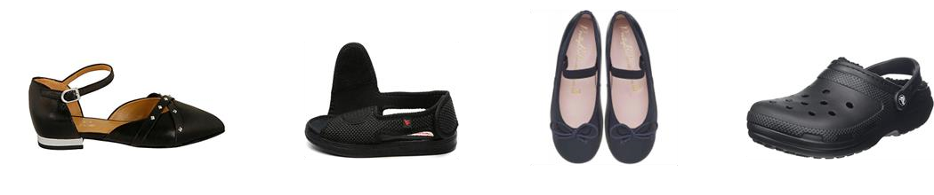

Socks must be of a dark colour, plain, inconspicuous and not patterned.

## 7. Washing of uniforms

It is the students responsibility to keep their uniform clean, ironed and in good order. Clothing must be clean and needs to be washed at the hottest temperature suitable for the fabric after each wearing. If there is a known exposure to an outbreak of cdifficile or MRSA items must be washed at 60°c. Uniforms and workwear should be washed separate to other items.

## 8. ID badges

University ID badges (and Trust or organisation ID badges if supplied) should worn at all times when on placement. This must be worn on a clip, students in clinical areas must not use a lanyard for safety purposes. Name badges should be clearly worn if supplied. No other badges should worn with uniform.

## 9. Jewellery/adornments

Wearing of rings is limited to one smooth band – no ridges or stones. Wrist watches not to be worn in clinical areas at any time and this includes other items worn on the wrist including Fitbits/Smart watches etc. One pair of plain ear studs only. Small discreet facial piercings are permitted but these must consist of a small plain hoop or stud and should not be excessive. All other piercings must be removed. If students have other piercings that cannot be removed these must be covered with a waterproof plaster and changed as required. Wearing of necklaces is not permitted for the same reasons as ID lanyards for personal safety. Bangles should not be worn, though if a bangle is worn for religious reasons then it must be pushed up the wrist and taped out of the way to ensure effective hand hygiene can be performed and reduce risk of injury to patients when performing clinical care. No nail varnish/polish is allowed and nails are to be kept clean and short. No nail extensions or false nails allowed. This includes gel or acrylic polish. Fake eyelashes are not be worn. Where there are visible tattoos or piercings these should not cause offense to others. Body art (e.g. tattoos) need to be sensitive towards other people’s perceptions and/or feelings and, if appropriate, should be covered. Offensive tattoos (visible tattoos which are inflammatory, rude, lewd, racist, sexist, sectarian, homophobic, violent or intimidating will not be permitted).

## 10. Hair

Hair is to be tied back off the collar. Facial hair must be clean and well groomed. Long beards must be contained within a cover/net. Turbans/Hijabs/hair coverings for religious reasons are permitted and these must be changed and washed regularly.

## 11. Wearing of uniform outside of placement

Uniform should not be worn outside of placement areas for infection control and safety purposes, unless on business for that placement provider, e.g. travelling to a patients home to deliver treatment or to a Trust meeting at different premises. Where there are no on-site changing facilities, students may wear uniform to travel to and from work, but it must be covered as much as is practically possible.

## 12. Personal Protective Equipment

Any PPE required for the requirements of clinical practice will be supplied by your placement organisation. Single use protective clothing – aprons and gloves, masks etc, must be worn for individual patient care where appropriate, then removed and disposed of safely once that care has been completed. Always refer and adhere to the placement providers PPE policy when on placement experiences.

## References and Bibliography

Birmingham Community Healthcare NHS Foundation Trust Uniform and Dress Code Policy (V3)2022.

Birmingham & Solihull Mental Health Foundation NHS Trust Workwear Policy (V4) 2020.

NHSI and NHSE (2019) National Hand hygiene and personal protective equipment policy. NHSE (2020) Uniforms and workwear: guidance for NHS employers available from

<https://www.england.nhs.uk/wp-content/uploads/2020/04/Uniforms-and> Workwear-Guidance-2April-2020.pdf

The Control of Substances Hazardous to Health (COSHH) Regulations 2002 Personal Protective Equipment at Work Regulations 1992.

The Dudley Group of Hospitals NHS Foundation Trust unform and workwear policy (v7) 2019

The Health and Social Care Act 2008: Code of Practice for health and adult social care on the prevention and control of infections and related guidance revised 2015

University Hospitals Birmingham Dress and Uniform Code (V5) Feb 2020.