Sept 2025 BSc Nursing Year 1 Programme Planner

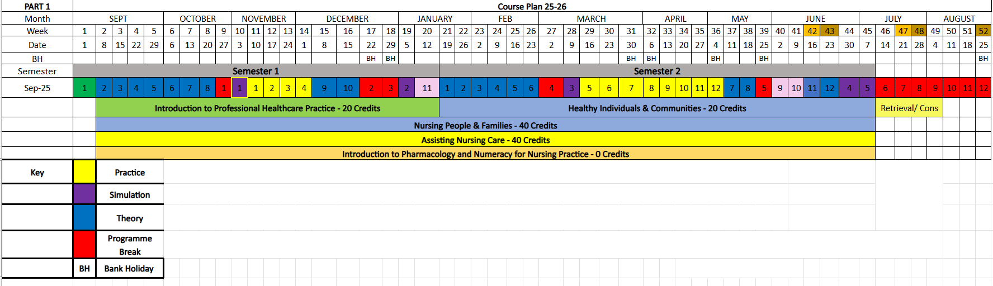

NB: This planner may be subject to change based on the needs of the programme. If a change occurs this will be communicated to you in a timely manner where possible.